**Module-6: Ansible Assignment – 1**

You have been asked to:

● Setup Ansible cluster with 3 nodes

● On slave1 install java

● On slave 2 install mysql-server

Created 3 ubuntu instances

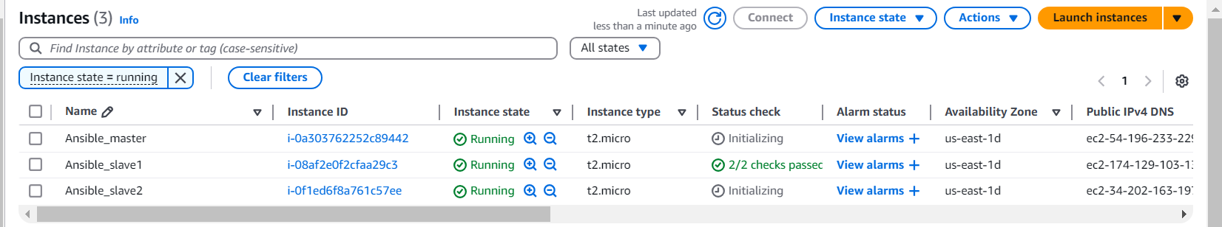

Install Ansible on Master



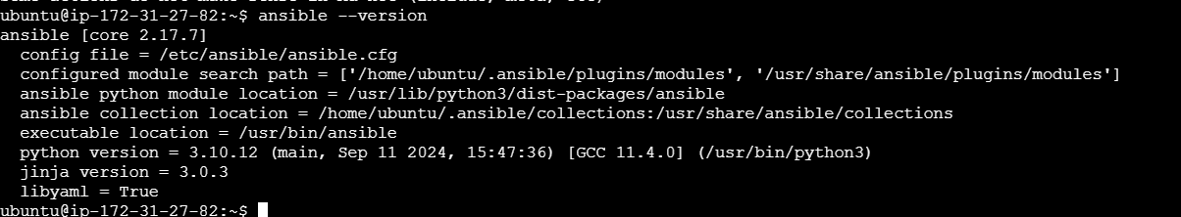

Do the above tasks using Ansible playbooks

Create key on master by ssh-keygen and copy the key into 2 slaves in authorized file

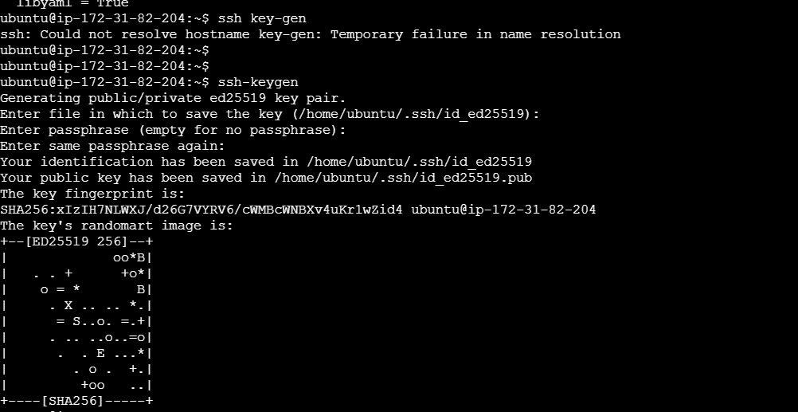



Copy above key on slave machine on path and in authorized_keys file

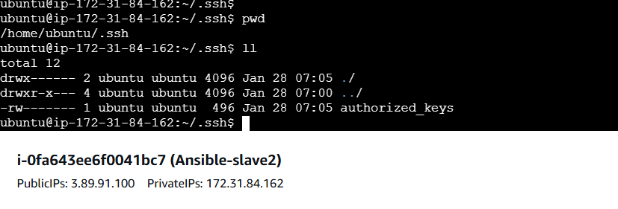

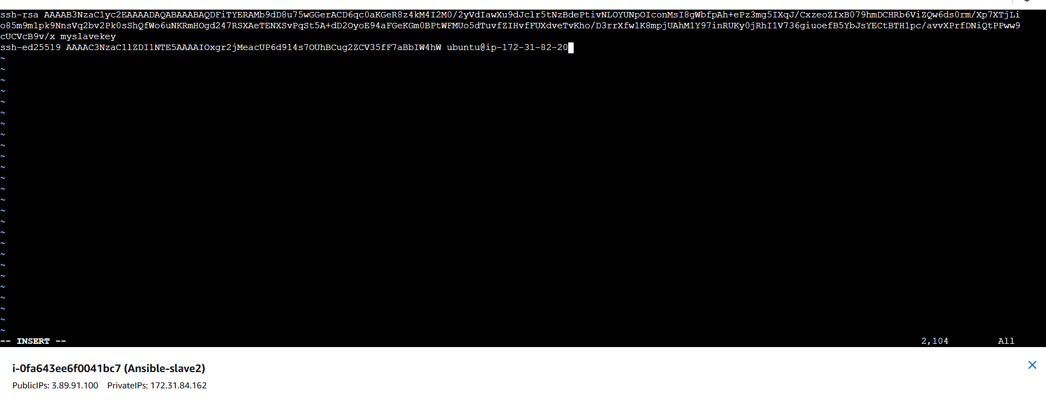

On master

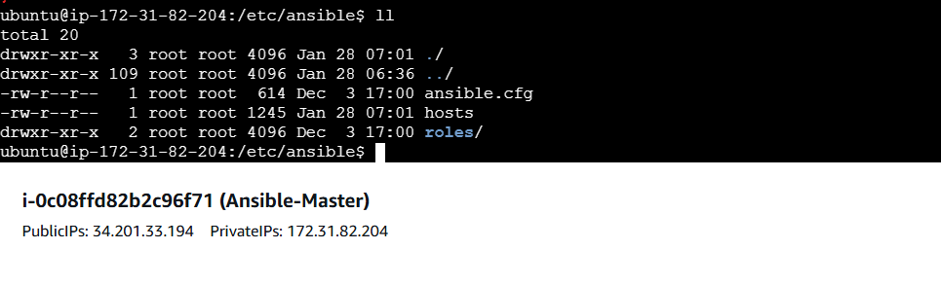

In hosts file add private Ip of 2 slaves

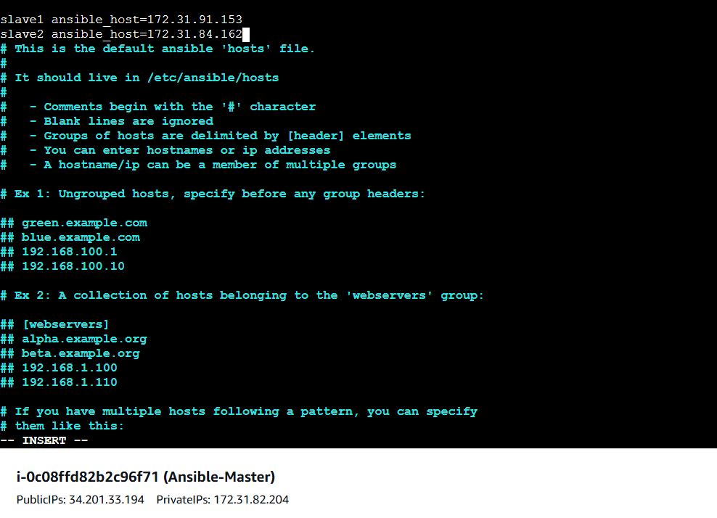

And verify the cluster by ping cmd

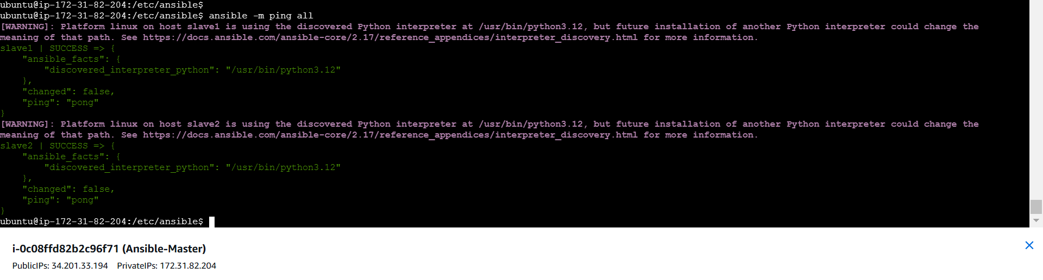

Create play1.yaml file for tasks

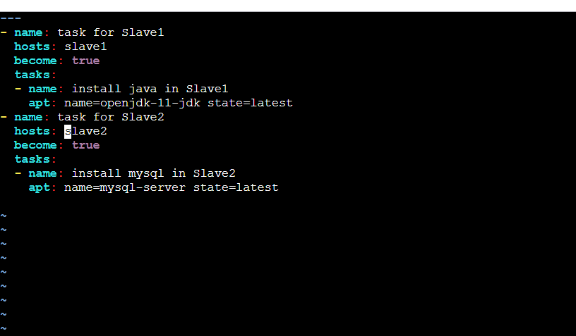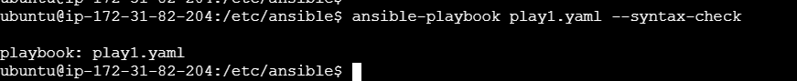

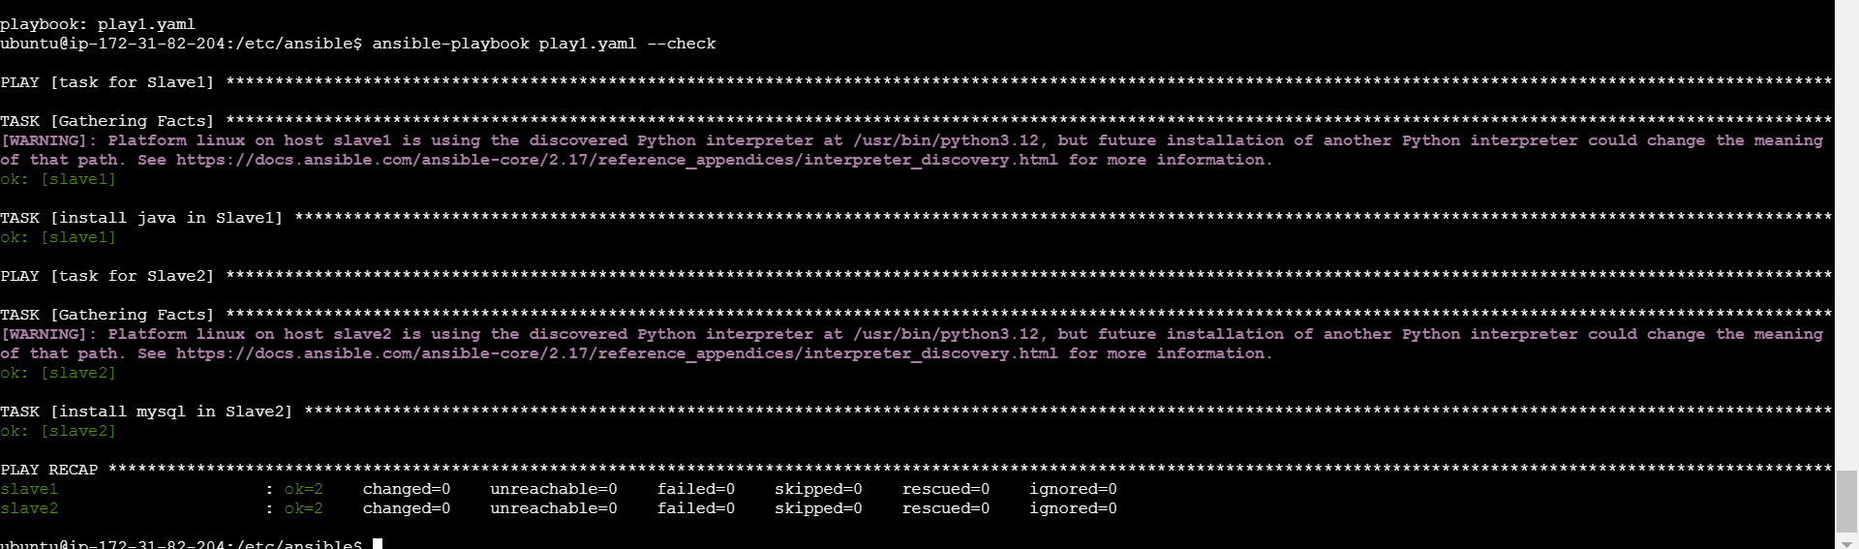

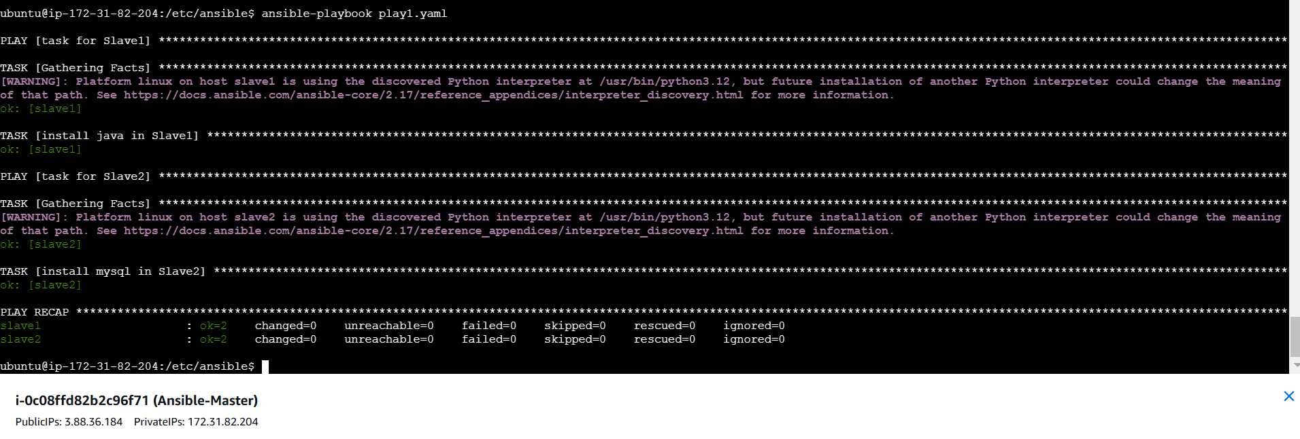

Verify

On slave1 jave is installed

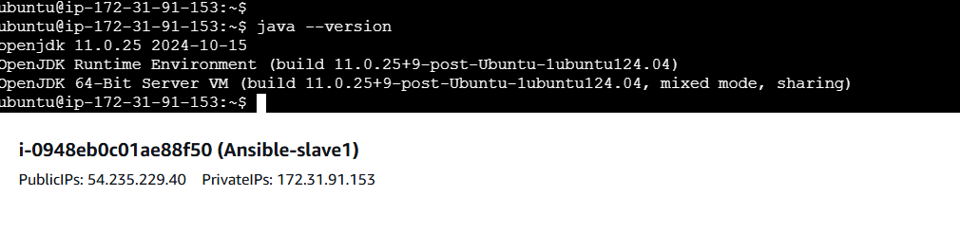

On slave2 mysql is installed

